KLH3 - Display Activity type group

Functionality

Activity Types can be grouped to facilitate reporting and cost allocation.

Scenario

This transaction is used to display an activity type grouping.

Requirements
Activity type group must be created.
.

Menu Path | Accounting → Controlling → Cost Center Accounting → Master Data → Activity Type Group → KLH3 - Display
Transaction Code | KLH3

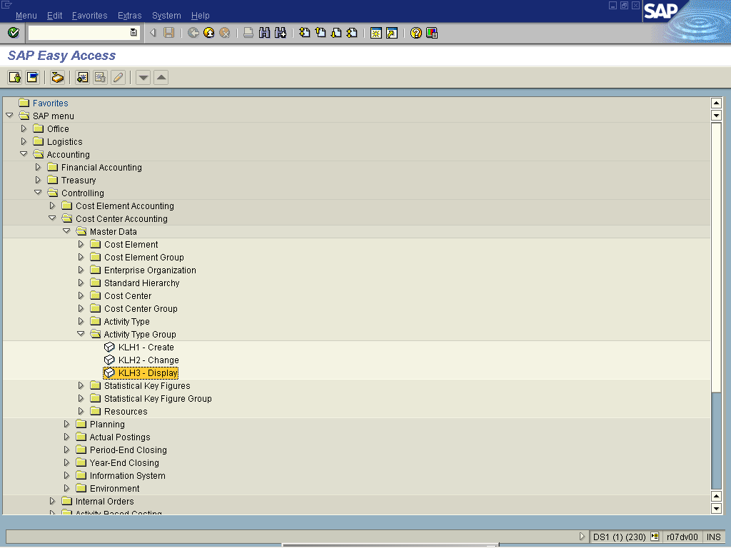

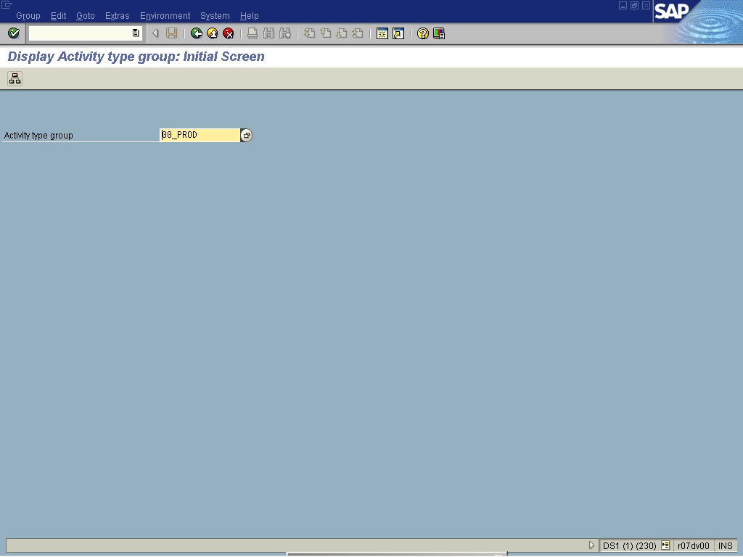

1. Update the following fields:

Field Name | Field Description | Values
Activity type group | Activity types describe the activity produced by a cost center and are measured in units of time or quantity. | Example: 00_PROD

2. Click Display menu of an activity group .

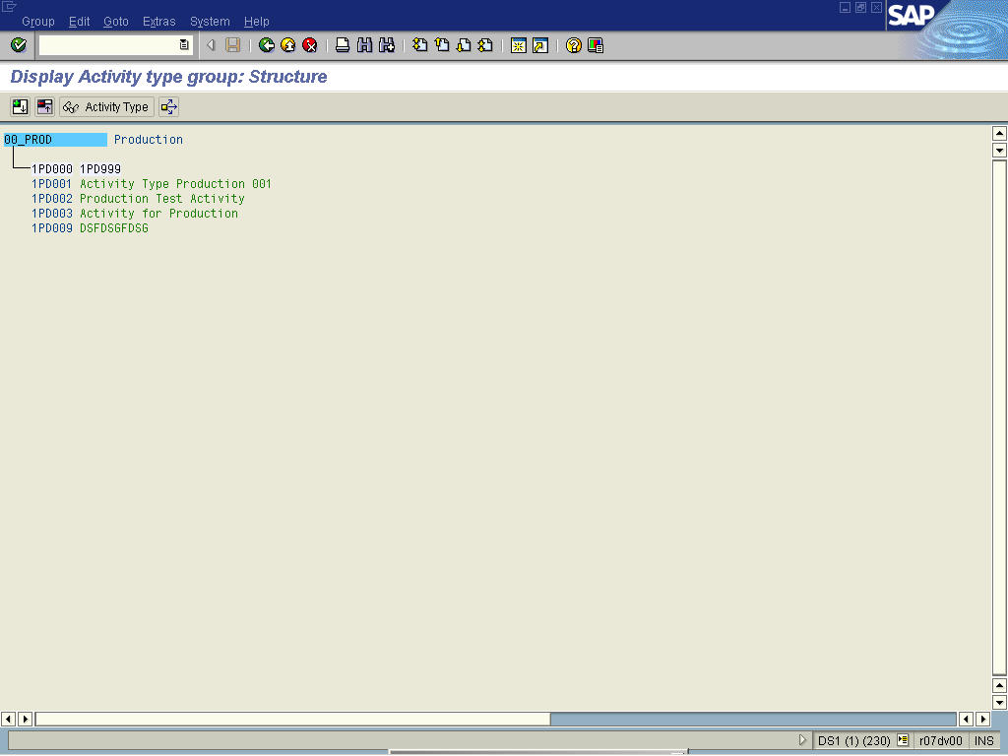

3. Click Back

